1. What is element?
A. An HTML element is the collection of start and end tags with the content inserted in between them. Syntax :
<tagname > Contents... </tagname>
Example : <p>My first paragraph.</p>
Nested HTML Elements: The HTML element is use inside the another HTML Element is called nested HTML elements.
Necessary to add end tag: It is necessary to add the end tag of an element. Otherwise, the displayed content may or may not be displayed correctly.
Empty HTML Elements: HTML Elements without any content i.e, that do not print anything are called Empty elements. Empty HTML elements do not have an ending tag. For instance. <br>, <hr>, <link>, <input> etc are HTML elements.
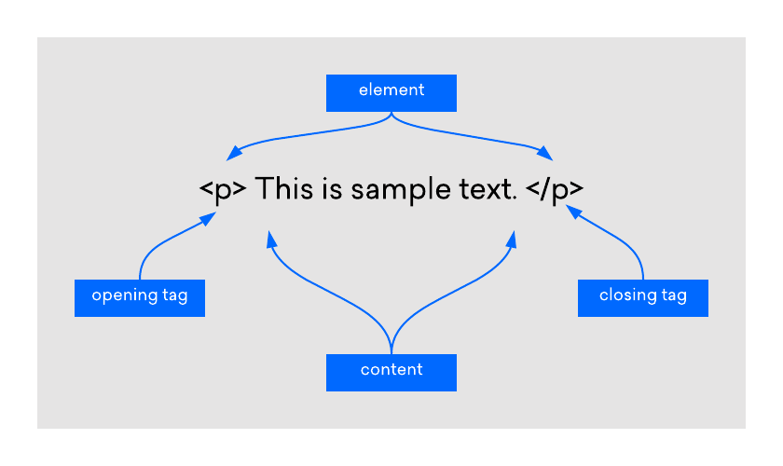

2. ID and Classes in HTML page.
A. Class in html:
- The class is an attribute which specifies one or more class names for an HTML element.
- The class attribute can be used on any HTML element.
- The class name can be used by CSS and JavaScript to perform certain tasks for elements with the specified class name.
Using multiple classes: HTML elements can have more than one class name, where each class name must be separated by a space.
Using same class in different tags: Different tags, like <h2> and <p>, can have the same class name and thereby share the same style.
ID in html:
The id attribute is a unique identifier that is used to specify the document. It is used by CSS and JavaScript to perform a certain task for a unique element. In CSS, the id attribute is used using the # symbol followed by id. quotes are not mandatory in tag=” ” in all cases. But writing with quotes is a good practice. Syntax:
<tag id=""></tag>
Use of ID attributes in JavaScript: In JavaScript, the id attribute is used to manipulate the text, if you want to make changes to a precise element in your script, then you can use the id attribute.

3. Difference between ID and Classes.
A. ID and Class difference
S. No. | Key | ID | Class
1 | Syntax | In Html for an element ID name starts with the “#” symbol followed by a unique name assigned to it. | On the other hand class assigned to an element has its name starts with “.” followed by class name.
2 | Selector | Only one ID selector can be attached to an element. | Multiple class selectors can be attached to an element.
3 | Uniqueness | Id is unique in a page and can only apply to at most one element | The class can be applied to multiple elements so it could be multiple times on a single page.

4. Can we use two classes in same element?
A. Yes. HTML elements can be assigned multiple classes by listing the classes in the class attribute, with a blank space to separate them. Syntax :
<tag_name class="class_1 class_2">

5.Can we use two id in same element?
A. No. If you have multiple elements with the same ID, you’ll only run into problems when using JavaScript to access those elements. For example, if you were to do document.getElementById('duplicateId'), you would only get back one element instead of two. Other than that, the browser will render the page just fine. Any CSS used to style that ID will work on both as well.

6. In same page can we use id and classes two times?
A. You can only have one ID per element, but you can indeed have more than one class. But don't have multiple class attributes; put multiple class values into one attribute.

7. Difference between html css and js
A. Lets consider a web page as a human body. Now let’s see what each of these language really do:
- HTML is a structural language that build the structure of a website as the skeletal system form the structure of the human body. Heading, paragraphs, images, text all are the part of HTML that creates the basic structure of a website.
- CSS is a styling language that gives styling of a website. With the help of front color, background color and border styling CSS furnishes the look of the site as the skin gives look to the human body.
- JavaScript is a programming language that gives motion and logics to the website for example a popup window alert. It is just like the motion of human body.

8. Can we use condition in html, css and js?
A. HTML:
HTML, as it is a markup language and not a programming language. You need to do it either server side or with Javascript.
CSS:
CSS Conditional Rules are nothing but a feature of CSS in which the CSS style is applied based on a specific condition. So the condition here can be either true or false and based on the statements/style will get executed.
These rules eventually come under CSS at-rule as they start with an @.
The Conditional Rules are:
- @supports
- @media
- @document
Java :
Conditional statements control behavior in JavaScript and determine whether or not pieces of code can run.
There are multiple different types of conditionals in JavaScript including:
- “If” statements: where if a condition is true it is used to specify execution for a block of code.
- “Else” statements: where if the same condition is false it specifies the execution for a block of code.
- “Else if” statements: this specifies a new test if the first condition is false.

9. What is single page application?
A. A Single Page Application is a website or web application that dynamically rewrites the current web page with new data from the web server, instead of the default method of a web browser loading entire new pages.
Single page application (SPA) is a single page (hence the name) where a lot of information stays the same and only a few pieces need to be updated at a time.
Single Page Application, after the initial page load, the server doesn’t send any more HTML to you - you download it all right at the beginning.
Because the server doesn’t need to spend time & energy doing the full drawing, SPAs lower the impact on your servers overall: meaning you can save money by using less servers for the same amount of traffic.

10. What is inline and external css, differentiate them.
A. External CSS :
With external CSS, you’ll link your web pages to an external .css file, which can be created by any text editor in your device.
This CSS type is a more efficient method, especially for styling a large website. By editing one .css file, you can change your entire site at once.
<link rel="stylesheet" type="text/css" href="style.css" />
Inline CSS :
Inline CSS is used to style a specific HTML element. For this CSS style, you’ll only need to add the style attribute to each HTML tag, without using selectors.
This CSS type is not really recommended, as each HTML tag needs to be styled individually. Managing your website may become too hard if you only use inline CSS.
However, inline CSS in HTML can be useful in some situations. For example, in cases where you don’t have access to CSS files or need to apply styles for a single element only.

